1.Prepare a U disk（USB flash drive） with a storage capacity of at least 16 GB.

2.Right click and select format... Format U disk to FAT32 format,and change the
Volume label to WINPE ,click start to finish formatting.
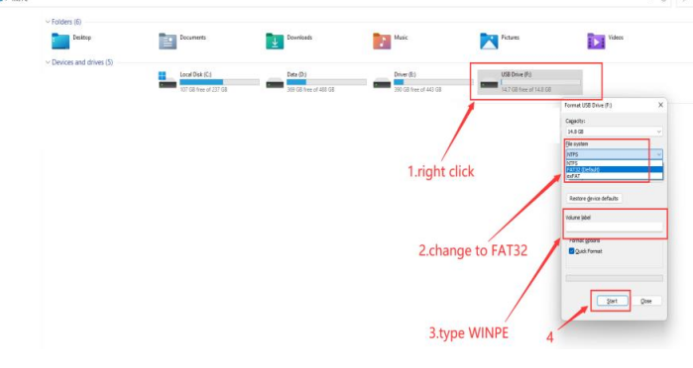

3.Copy the files to U disk as below, and it must be in the root directory of U disk.

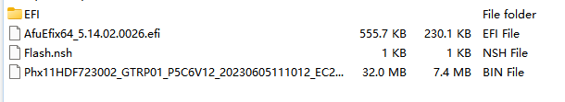

4.Restart the computer, press F7 repeatedly on the boot logo interface, and select
USB boot in the boot options.
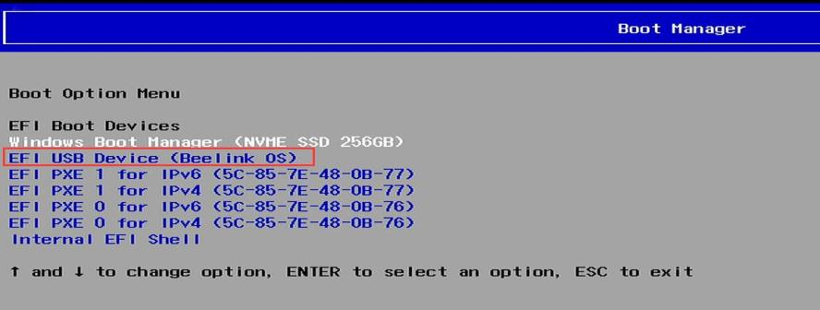

5.After then,please wait for it flash automatically until it complete.

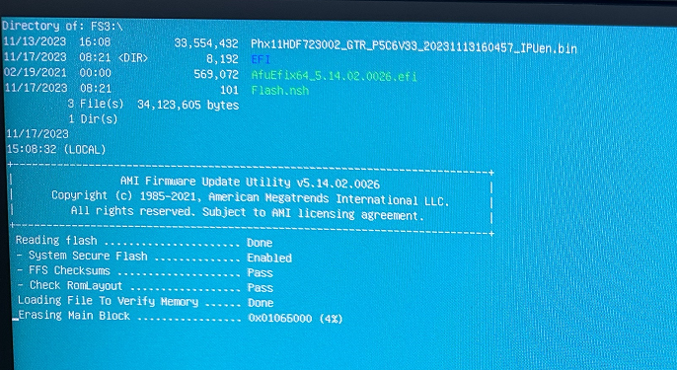
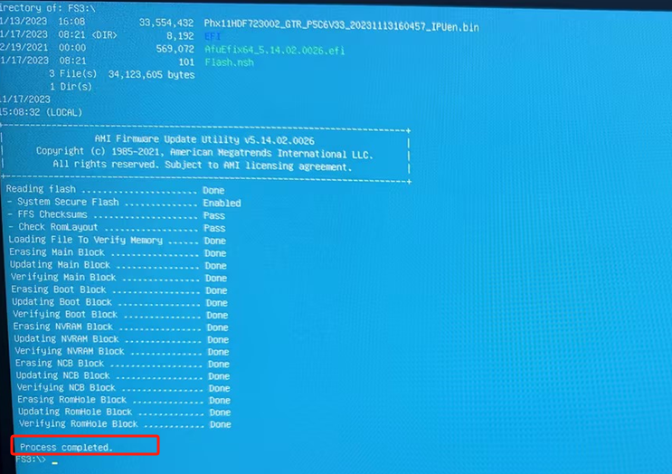6.Please enter exit.


