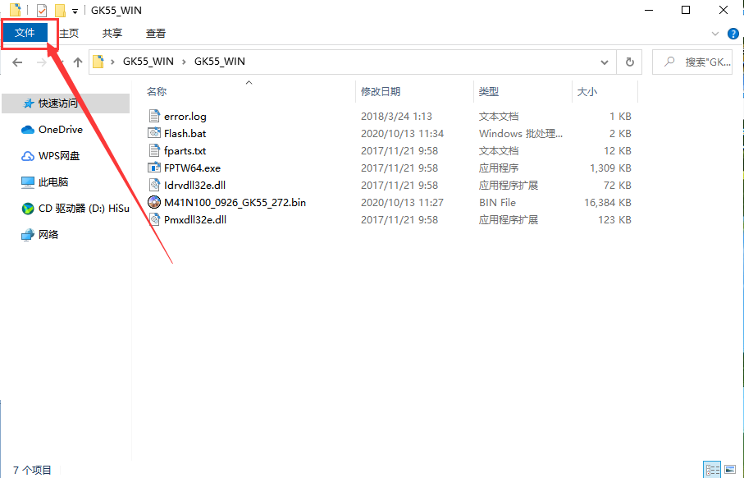

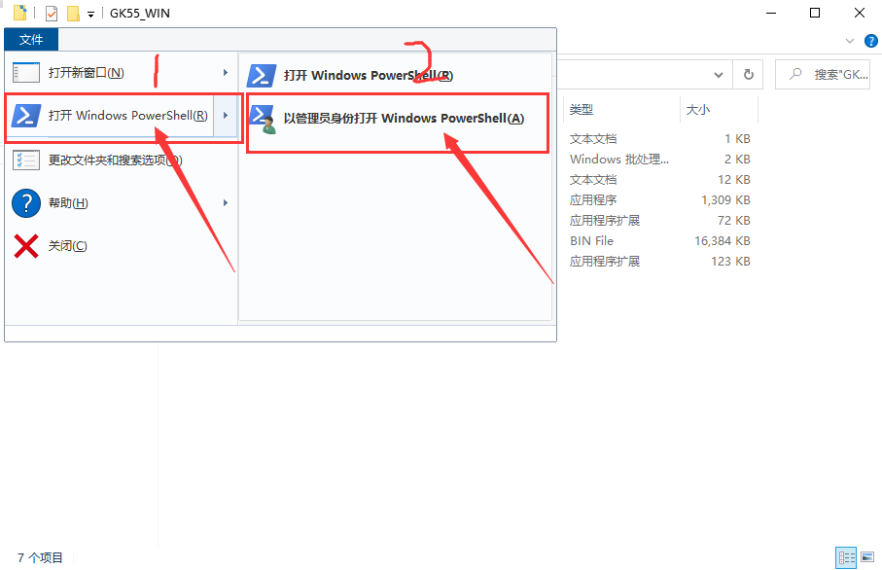

Then output in the Windows PowerShell window.\Flash.bat
Then press Enter to run
