The following EC patch can reduce the fan noise, it is also applicable to the BIOS version with UEFI mode.
Note: Please download the patch for the correct item model and SN on the bottom of your PC, otherwise, wrong patch will brick the PC.
Patches for the item model below(Please download the patch based on your item model)：
SER6/SER6 Pro：EC-ARB20A-1.11
GTR6 6900HX： EC_GTR6_V6_4_0_0_11F

The procedure of flashing EC patch：
1.）First, please download the patch file(please click the above download link),unzip the file , then you will get the files like the ones below, different item model has different files name.
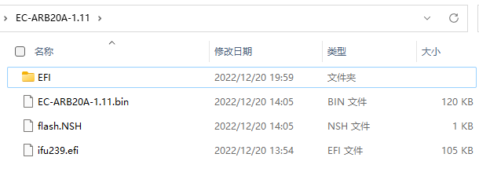
2.）Prepare a flash drive which is more than 1GB, format the USB flash drive to FAT32,please back up the files in the USB flash drive , because formatting the drive will remove everything in it.
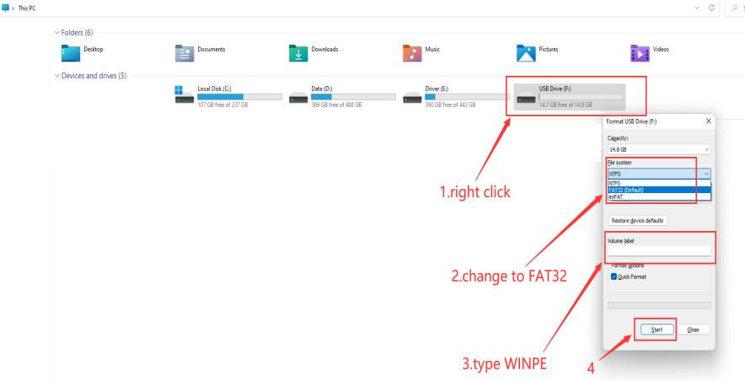

- Copy the files to USB drive, and it must be in the root directory of USB drive.Please eject the USB drive after it is done.
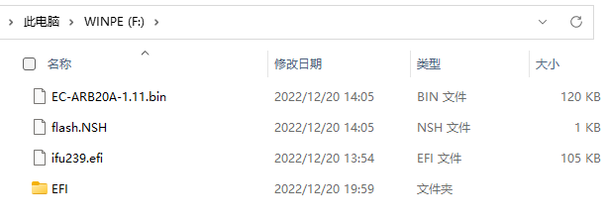
4.）Please put the USB drive to the USB port of the PC, then repeatedly press F7 as soon as you see the logo of Beelink,go to the boot menu.（Example model：SER6 Pro）。
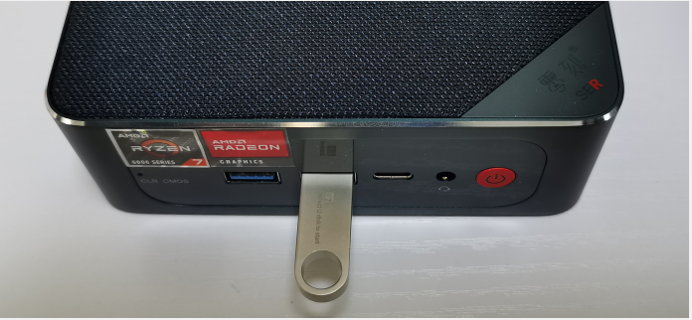
5.）Please select the USB flash drive with the arrow key, press enter to go to USB flash drive.
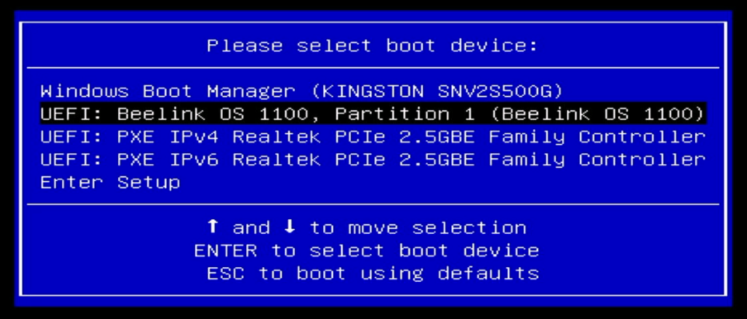
6.）It will go to UEFI page , a few seconds later, it will start flashing the new EC patch.
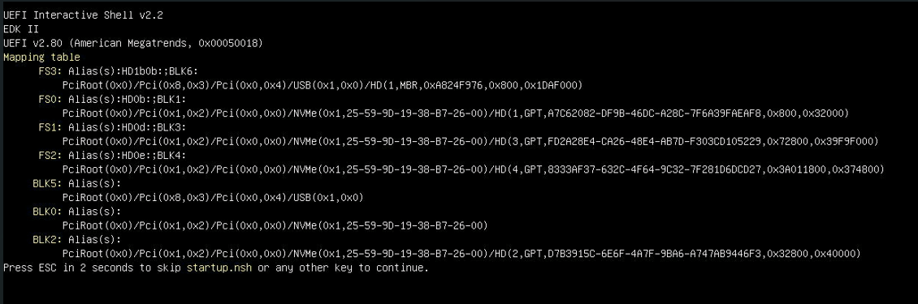
- ）It will automatically turn off after it is done. Then please unplug the USB flash drive to avoid flashing the EC patch again.
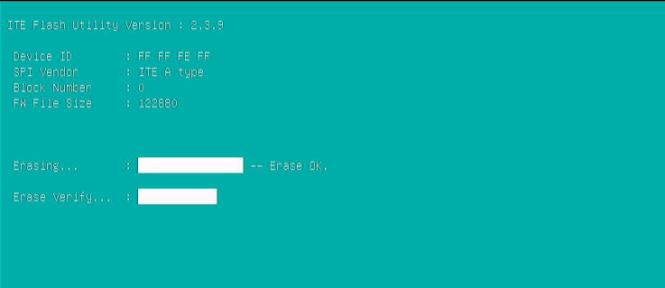
8.）Please press delete key as soon as you turn on the PC,go to BIOS. Please check the EC version in the Main page, if the version is the same as the one you downloaded, then it is successful.
