How to run a Large Language Model (LLM) on SER8 8845HS
Brief note:
Beelink SER8 8845HS is equipped with a built-in NPU (Neural Network Processing Unit), and can deploy its own GPT model AI chat robot through the Large Language Model (LLM). The AI assistant has quickly become a key resource for improving productivity, efficiency, and even brainstorming. Running an AI chat robot on a local machine not only does not require an Internet connection, but also your conversations are saved on the local machine.

AMD 8845Hs Ryzen AI
•AI engine performance: up to 16 TOPS (trillions of operations per second).

•Total processor performance: up to 38 TOPS.

Beelink SER8 IPU is enabled by default, you can check the device status in the device manager
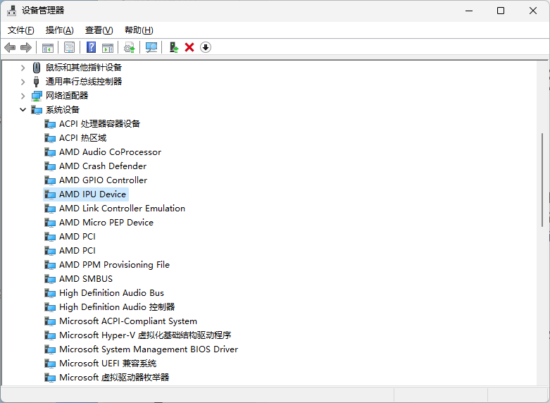

Procedures：

1.Download the LM Studio large model deployment software, click the link to enter the official website, https://lmstudio.ai/, and download the Windows version.
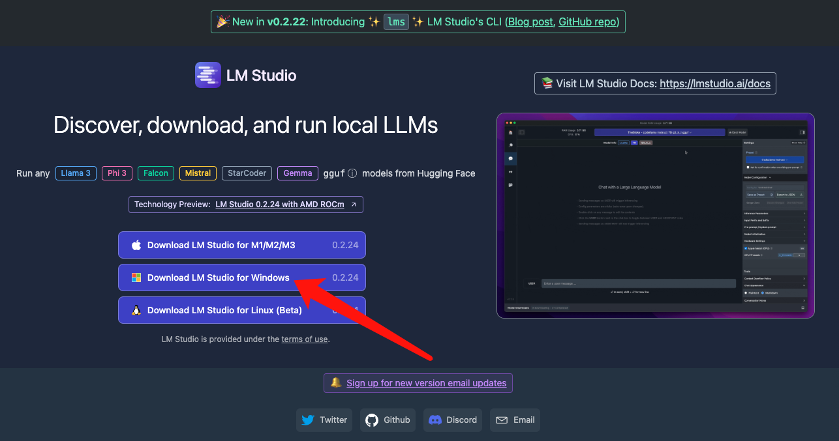

2.After the download is completed, double-click to start and enter the software interface.
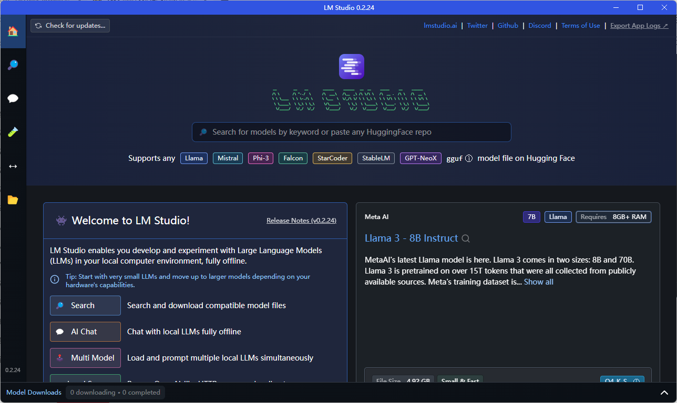

3.AMD officially provides two large language models , Mistral 7b (TheBloke/OpenHermes-2.5-Mistral-7B-GGUF) and LLAMA v2 7b (TheBloke/Llama-2-7B-Chat-GGUF). The 7b here refers to the large model trained with 7 billion parameters. We choose to download the LLAMA v2 7b language large model and click the left search button (if the search prompts a network error, you can view the solution to the error "Error searching for models 'Network error'" when deploying the LM Studio language large model deployment software to search for the language model).
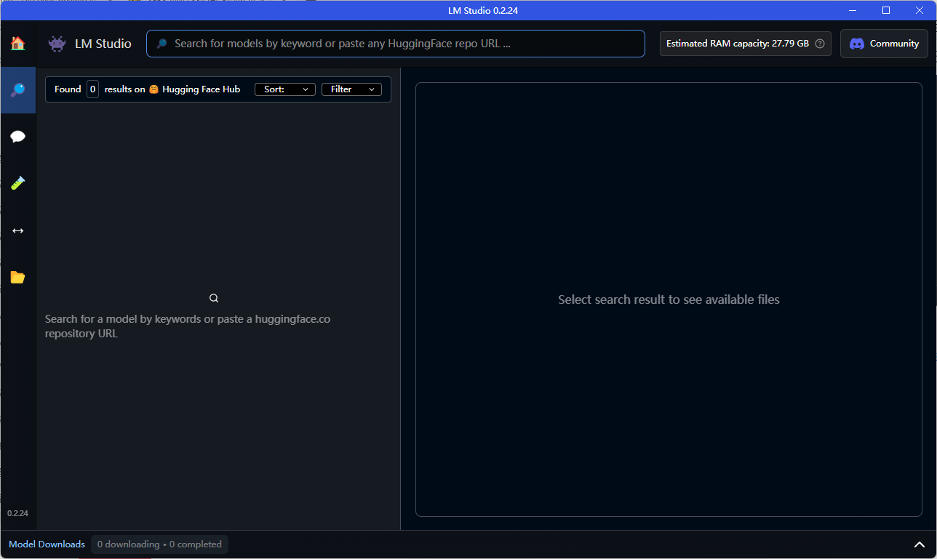

4.In the search bar, copy and paste the following search term: "TheBloke/Llama-2-7B-Chat-GGUF", select the 'Q4 K M' model file on the right, and click 'Download' to download it.
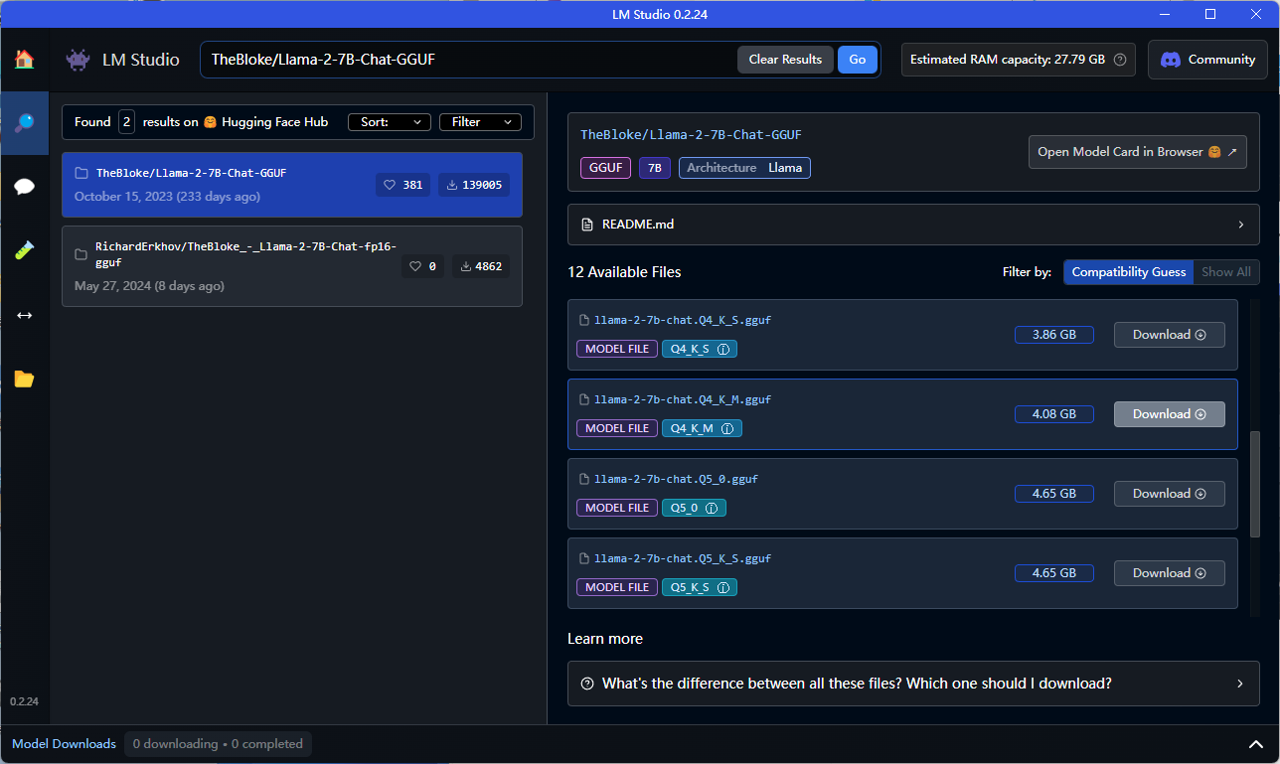

5.Wait until the download is complete
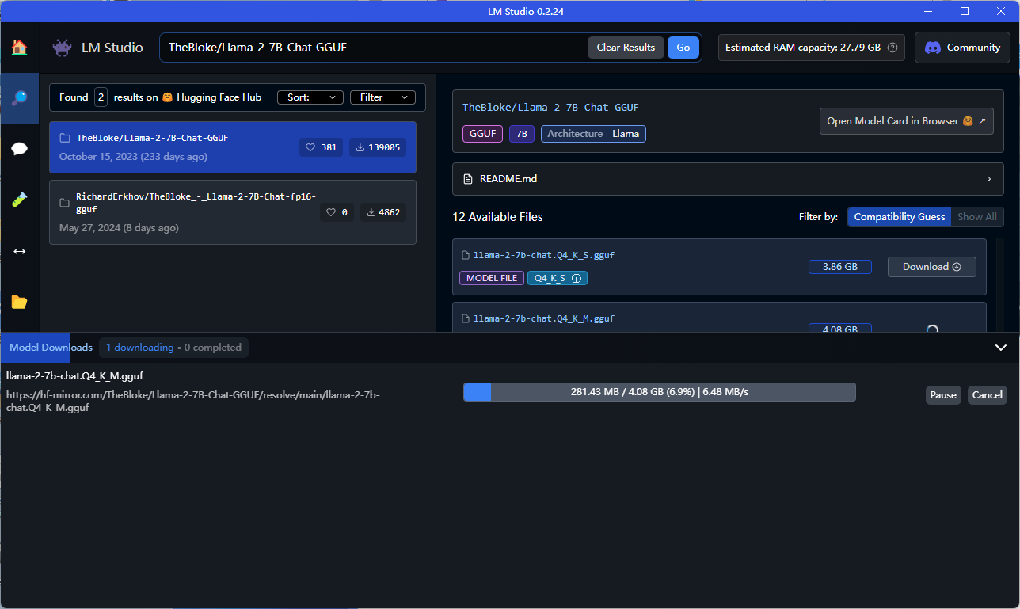

After the download is completed,please click the chat button on the left to switch to chatting mode.
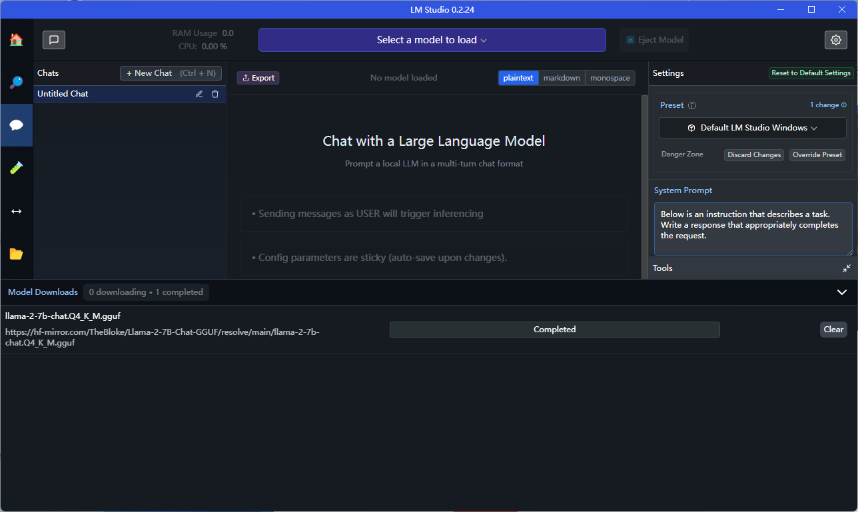

7. Click on the top to switch to the just-downloaded language large model package.
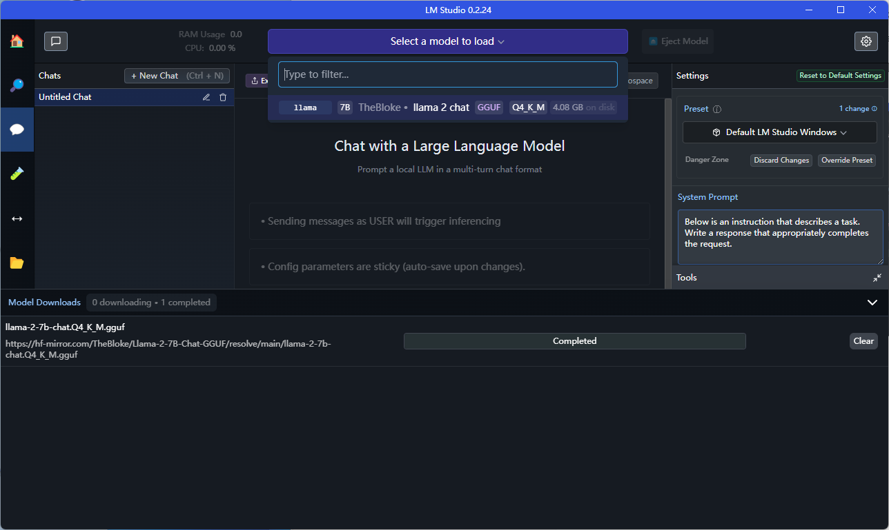

8. Wait for the model to finish loading and then it can be used. The LLAMA v2 7b model only supports English.
