Ubuntu Wake On Lan（WoL）Tutorial
After the PC turns off, we can wake up the PC by WOL once there is power outage.在设备关闭电源之后，我们可以通过局域网唤醒开机，此功能的主要目的在于预防突然断电等突发状况。
We’ll take Ubuntu 23.04 as an example:
本教程以Ubuntu 23.04版本为例
Please follow the steps具体操作步骤：
- Create systemd auto-start setting document 创建 systemd 自启动设置文件
Input the command输入命令：sudo vim /etc/systemd/system/wol.service
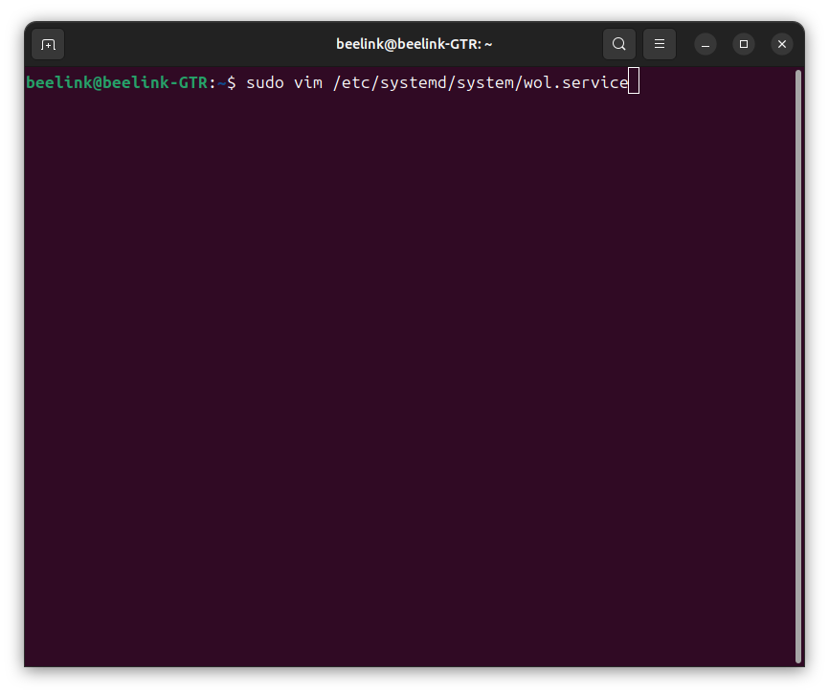
Copy and paste the below content放入以下内容：
[Unit]
Description=Wake-on-LAN for %i
Requires=network.target
After=network.target
[Service]
ExecStart=/sbin/ethtool -s %i wol g
Type=oneshot
[Install]
WantedBy=multi-user.target
Then please press :wq！to save 输入完成后按 :wq！进行保存
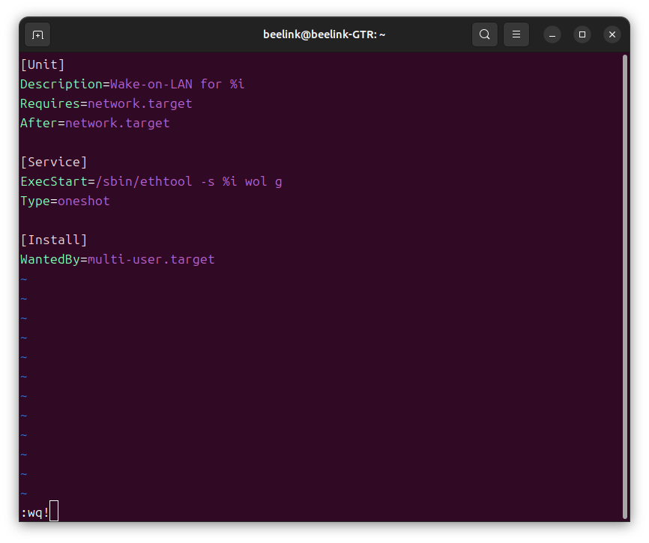
- Confirm the netcard name, and input the command: ip a
确定网卡名称，输入命令：ip a
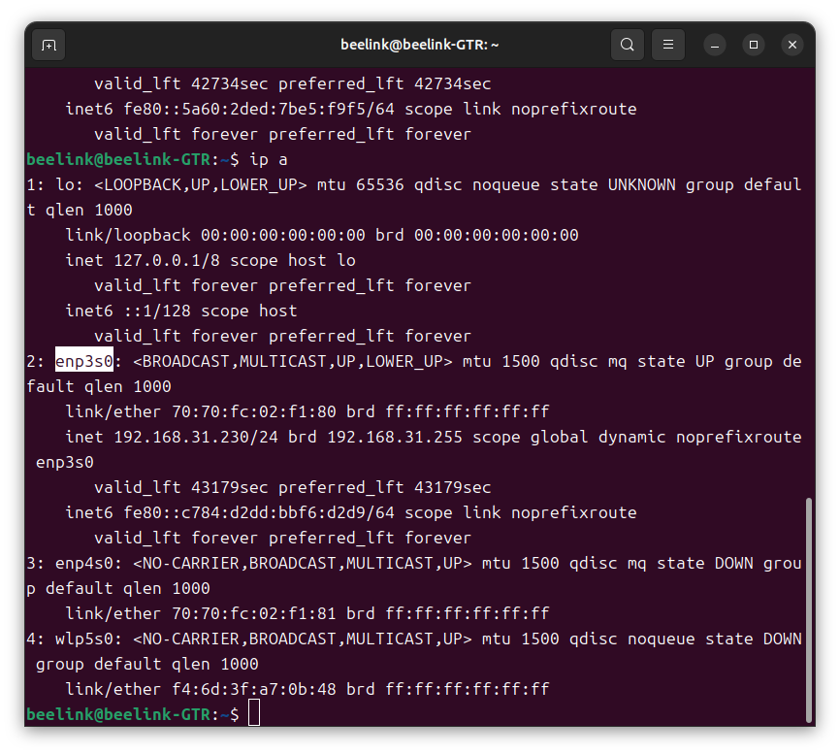
If you have more net card,you can use set it up depending on the one that you are using. My net card name is en3s0. Generally speaking, we usually set up the WOL by wired net card.
你如果你有多个网卡，可以根据自己的实际网卡来设置，我这里网卡名称是en3s0，一般来说，使用有线网卡进行 WoL 的配置。
- Start the command If of the pointed net card:systemctl enable wol@enp3s0
启用指定网卡的 WoL 自启动文件If 命令：systemctl enable wol@enp3s0
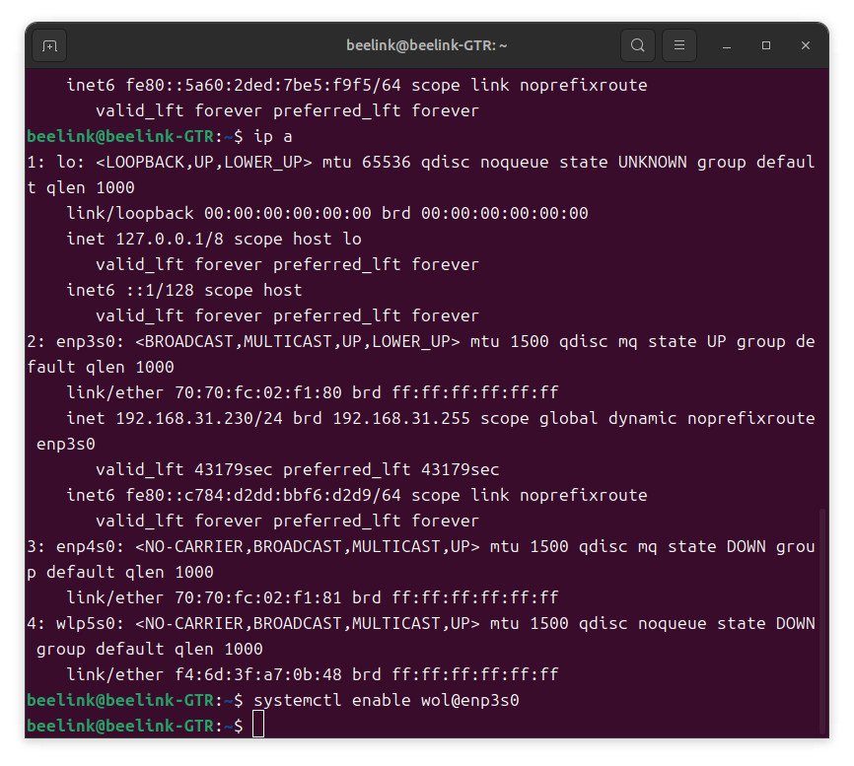
4.Start the command:systemctl start wol@enp3s0
启动命令:systemctl start wol@enp3s0
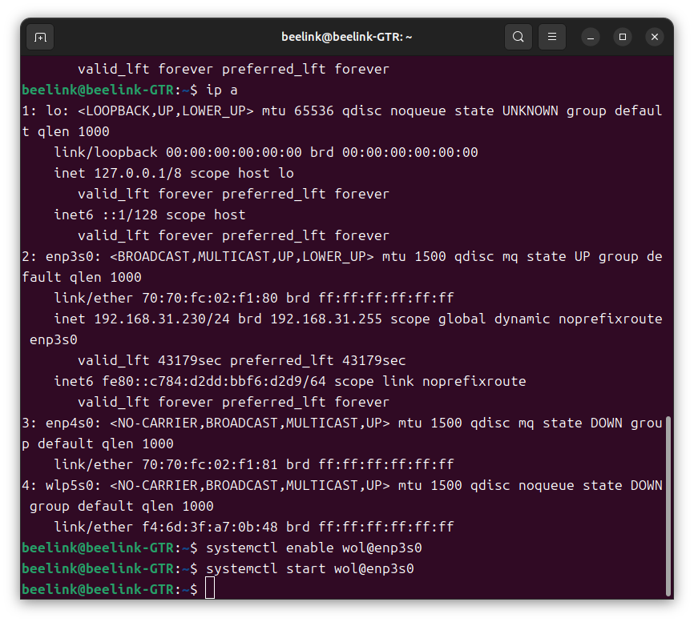
5. Test if it starts or not. Input the command : ethtool enp3s0
测试是否开启 命令：ethtool enp3s0
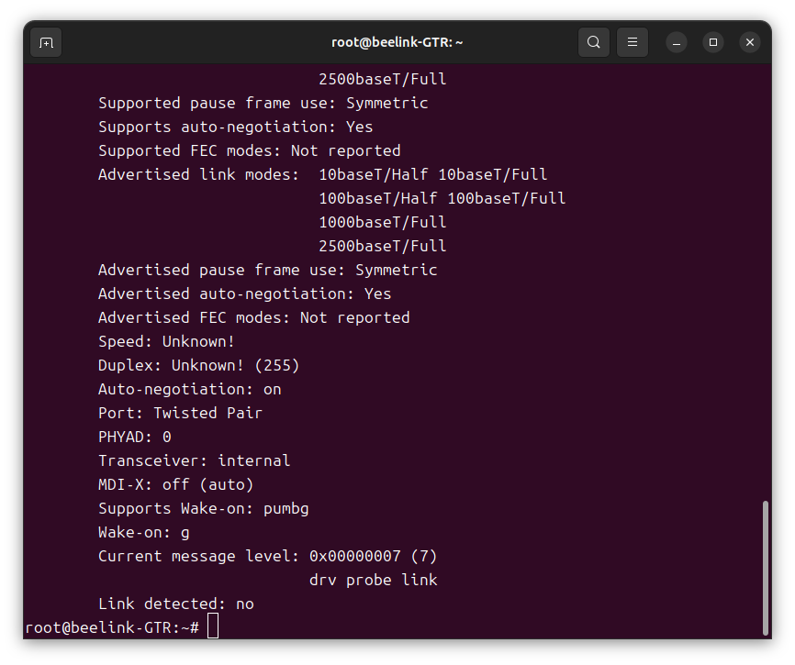
Then you can see that the setting of Wake-on：g is activated. It is still activated after restarting the PC.
可以看到 Wake-on：g配置已经生效。重启后再次尝试，配置依然生效。

You can use etherwake to wake up the device under Linux, here is the tips: etherwake -b [This is the mac address of the device used to be waken up]
Linux 可以使用 etherwake 唤醒设备，使用方式：
etherwake -b [被唤醒设备网卡的mac地址] -i [发出唤醒请求的网卡名称]

Also,you can use wakeonlan to wake up the device, tips:
wakeonlan[被唤醒设备网卡的mac地址]

也可以使用 wakeonlan 唤醒，使用方式：
wakeonlan [The mac address of the device used to be waken up]

