The instruction to flash BOIS via USB flash disk.

- Please unzip the “BOIS”and copy all the files in BOIS to the root directory of the USB flash disk.

- Please format the USB flash disk into the format of “FAT32”and rename it as “WINPE”.

3.The picture is the reference, the BIOS file is based on the actual downloaded BOIS file.

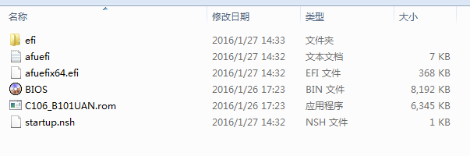

4. Please put the USB flash disk and USB keyboard to the tablet. Make sure that the tablet is off and then press the power button, at the same time, please click the “F7”continuously to enter the boot mode.
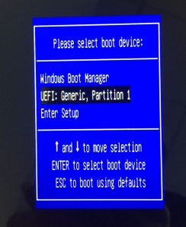
5.Choose “UEFI:Generis,Partition 1”to click “enter”. When the BIOS is finished flashing, please take off the USB flash disk to avoid flashing BOIS again.
