Introduction to flashing (reinstall)windows System
1. Preparation tools: 16G or more memory U disk

2. Note: Make sure the battery power exceeds 50%. Or plug in the power brush

3. Format the USB flash drive with the NTFS format label named WINPE (if the WINPE system is not named, the USB flash drive will not be recognized) as shown below.
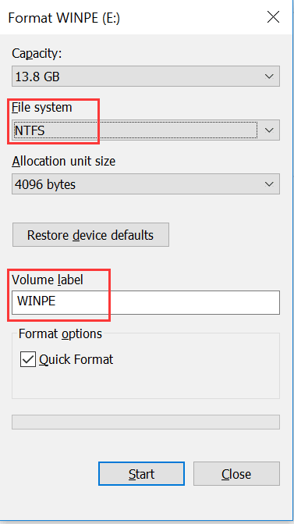
2. Unzip the downloaded package of the network disk, as shown below

Open the windows file package and copy the subfiles to the root directory of the U disk，
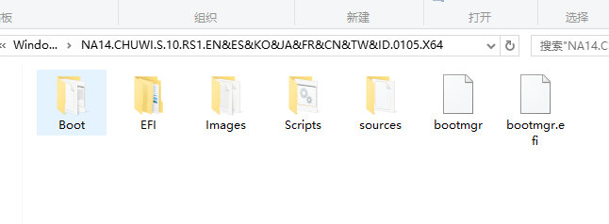
3. The method is to insert the USB flash drive into the computer. After turning off the computer, press the power button to turn it on. Press F7(or esc) at the same time, then select UEFI:Sandisk, and select partition 1 to select the USB flash drive to boot. The notebook will automatically install windows.
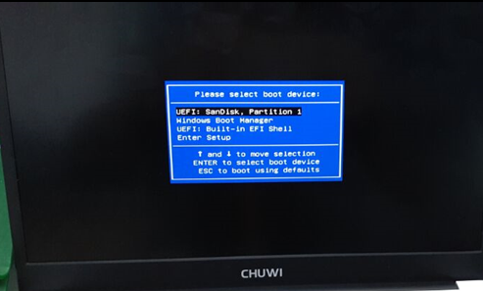
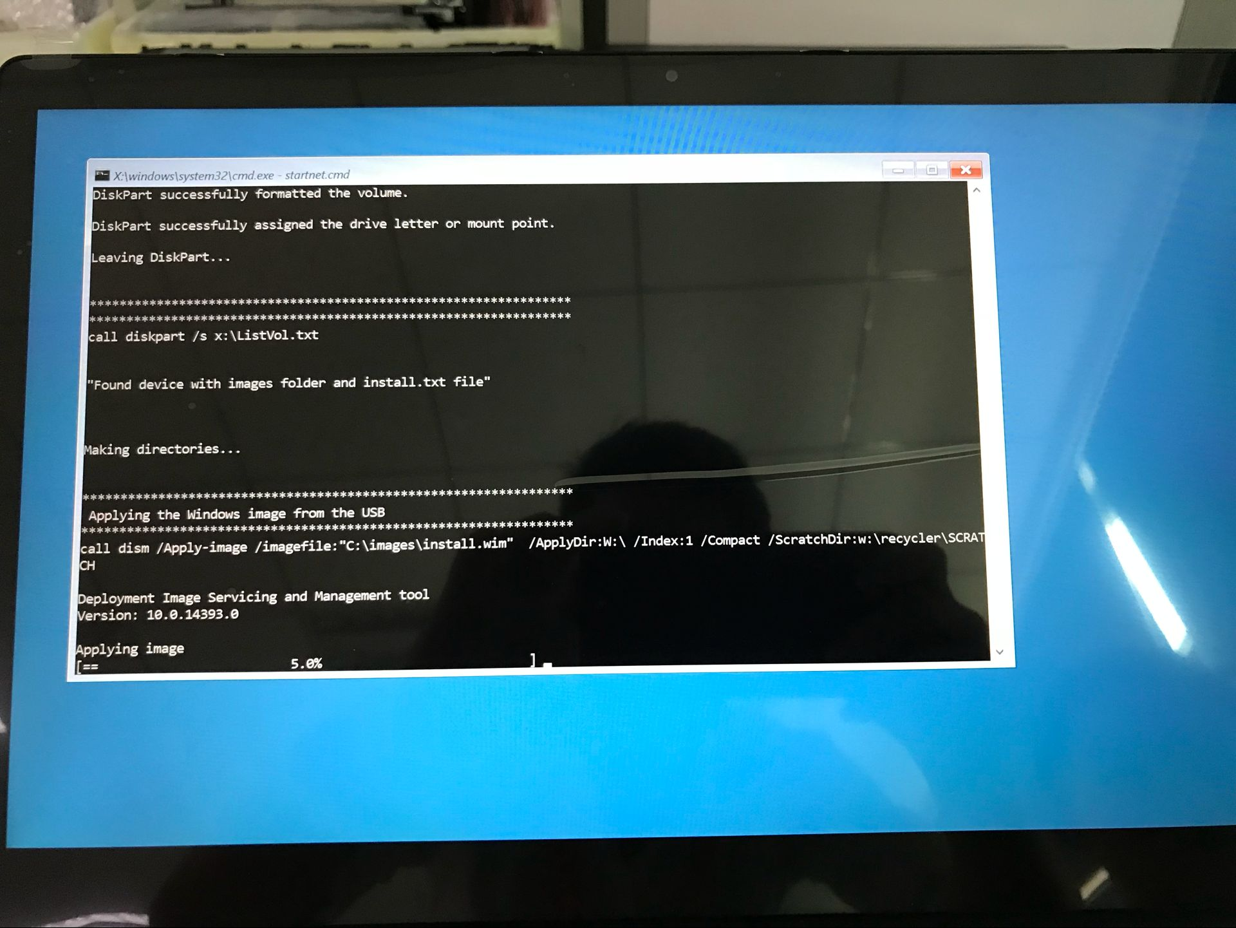

4. When this interface appears, it shows that the machine is normal.，
After the installation is complete, it will automatically shut down, unplug the USB drive and reopen the laptop.

After booting for the first time, enter the test mode and double-click the cleanup on the desktop.
