友情提示：刷机刷系统会删除磁盘里面原来的数据，请确认好之后再谨慎操作，
Friendly tip: Brush machine brush system will delete the original data in the disk, please confirm after careful operation

这边重装系统的操作不需要做U盘启动，如果用了老毛桃大白菜那些工具做过启动盘的U盘可能不行，
The operation of reinstalling the system does not need to make a U disk to start up. If you use tools like old peach and Cabbage to make a U disk to start up, it may not work.

把客服给的链接的系统下载好。准备一个16G U盘进行格式化，把名字改为“WINPE”，U盘的格式改为“NTFS”。
1.Download the link system given by customer service. Prepare a 16G USB flash disk for formatting. Change the name to "WINPE" and the format of USB flash disk to "NTFS".

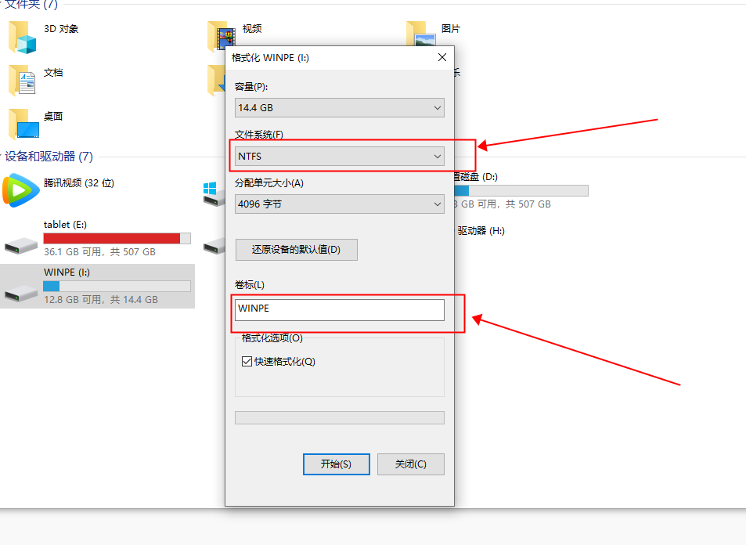

把下载好的系统解压，有些系统分成好几个部分解压的，同时选中他们解压到同一个文件夹. 把类似的系统目录拷贝到U盘。
2. Unzip the downloaded system, some systems are divided into several parts of the unzip, select them to unzip to the same folder .Copy a similar system directory to the USB flash drive.

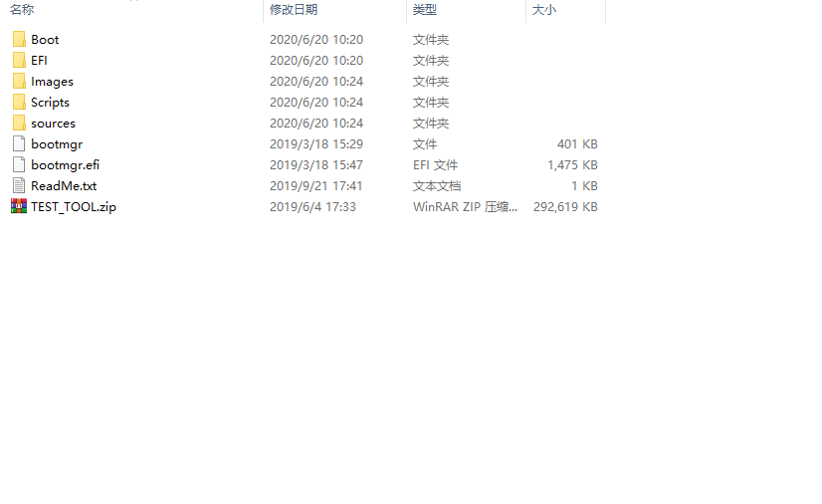

把16G的U盘插进miniPC的接口里，开机会显示这个页面，请耐心等几分钟
3. Insert the 16g USB flash disk into the minipc interface. This page will be displayed when the computer is turned on. Please wait a few minutes

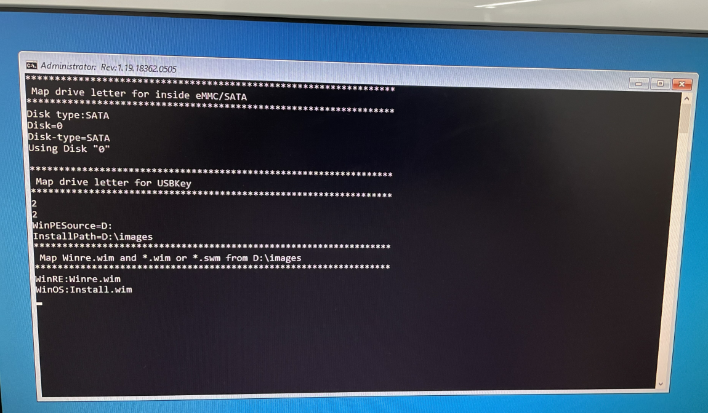

几分钟之后会出现下面这个页面，这个时候就是写入系统的时候，等进度条到100%就说明系统已经重新装好了。
4.The following page will appear in a few minutes. This is when the system is written. When the progress bar reaches 100%, the system has been reloaded.
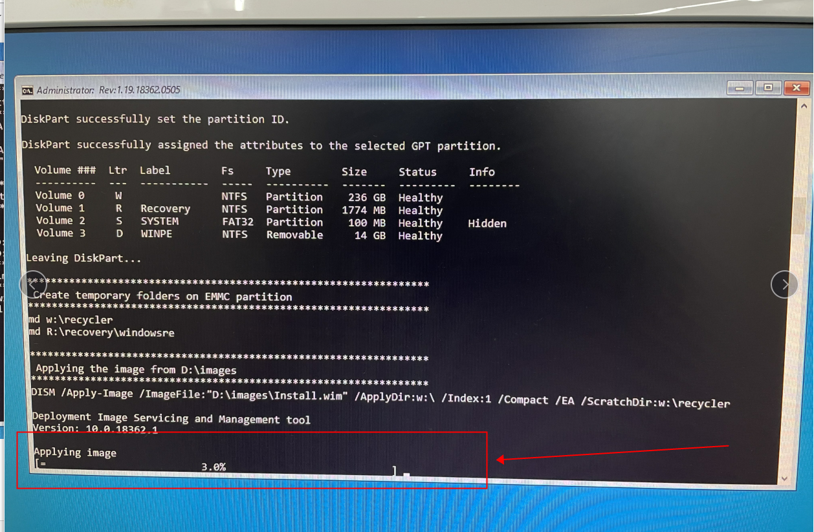

系统装好了以后会黑屏，像下面这张图片，这个时候我们要把U盘从电脑主机那里拔下来。
5.After the system is installed, the screen will be black, as shown in the picture below. At this time, we need to unplug the U disk from the computer host.
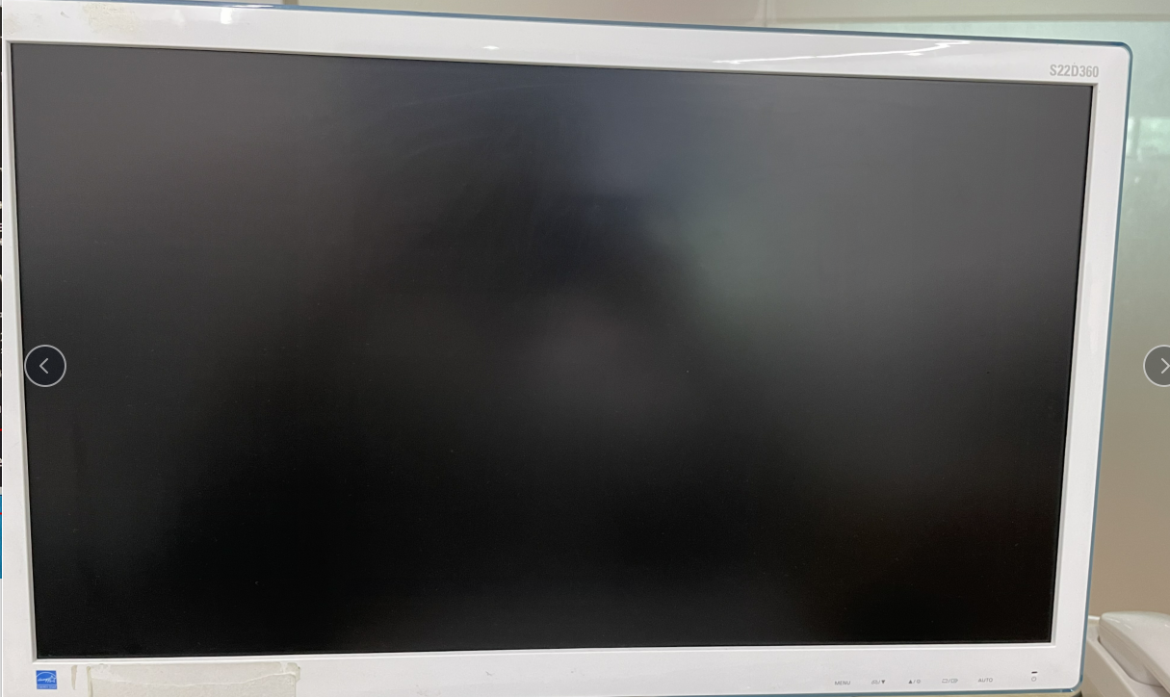

把U盘拔下来以后我们重新开机。第一次开机需要很长的时间，请耐心等待。
6.After we unplug the USB flash disk, we will restart. It takes a long time to start the machine for the first time. Please wait patiently.
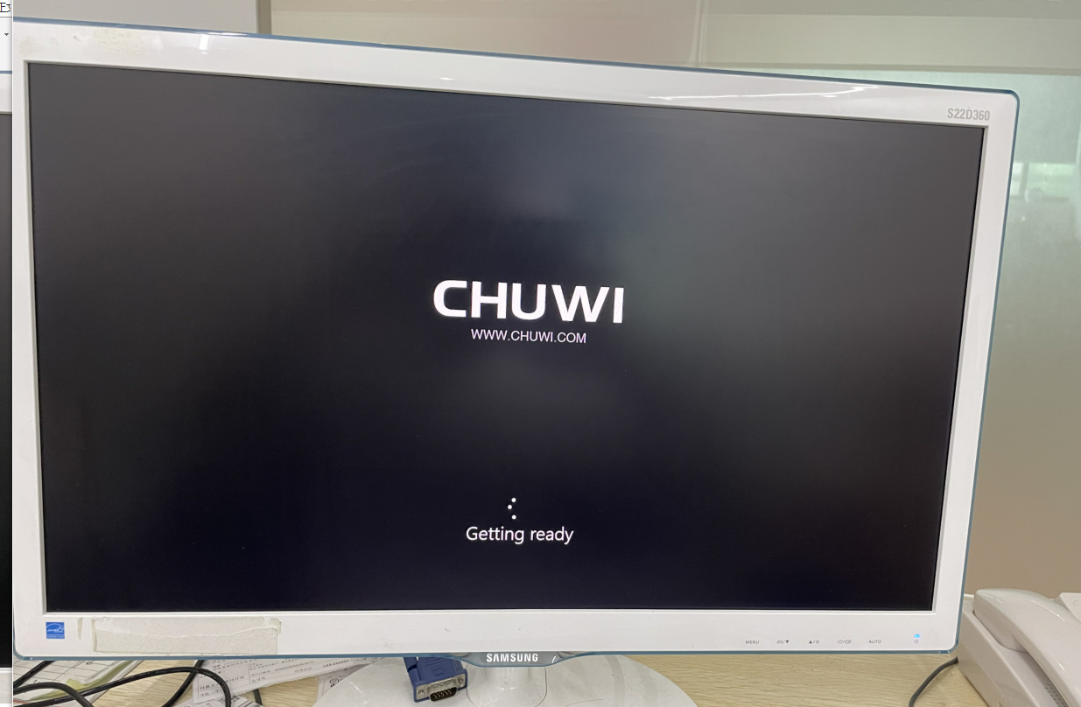

开机之后如果出现这个画面，是进入了测试模式。您可以双击"cleanupTest"那个图标退出。或者是按另外一个有“OK”的地方退出测试模式。
7.If this screen appears after startup, it is in test mode. You can double-click the "cleanuptest" icon to exit. Or press another place with "OK" to exit the test mode.
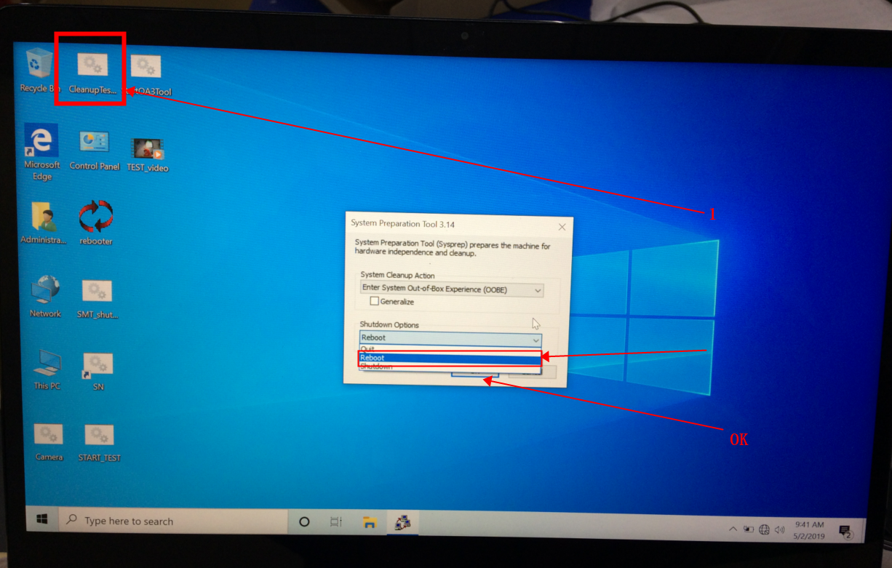
_____________________________________________
如果上面的办法不能够奏效，可以尝试进bios的办法设置开机启动项刷系统。
按下开机键等开机指示灯亮的时候,按键盘上的ESC键进入bios,就像下面的图片。
If the above method does not work, you can try to set the boot entry brush system in BIOS.
Press the power on button and when the boot indicator is on, press the ESC key on the keyboard to enter the BIOS, as shown in the picture below.

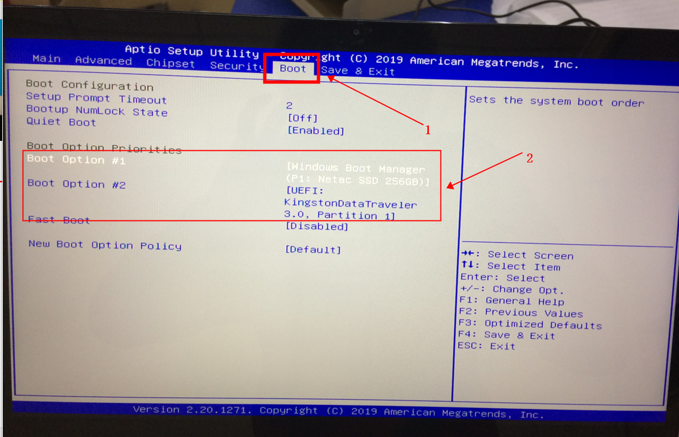

进入bios以后，选择boot的选项，找到“boot option #1”的地方，按回车键进入具体的选项，选择“UEFI”开头的选项，这个是U盘的启动选项。
After entering the BIOS, select the option boot, find the "Boot option #1", press enter to enter the specific option, and select the option beginning with "UEFI", which is the boot option of the USB flash drive.

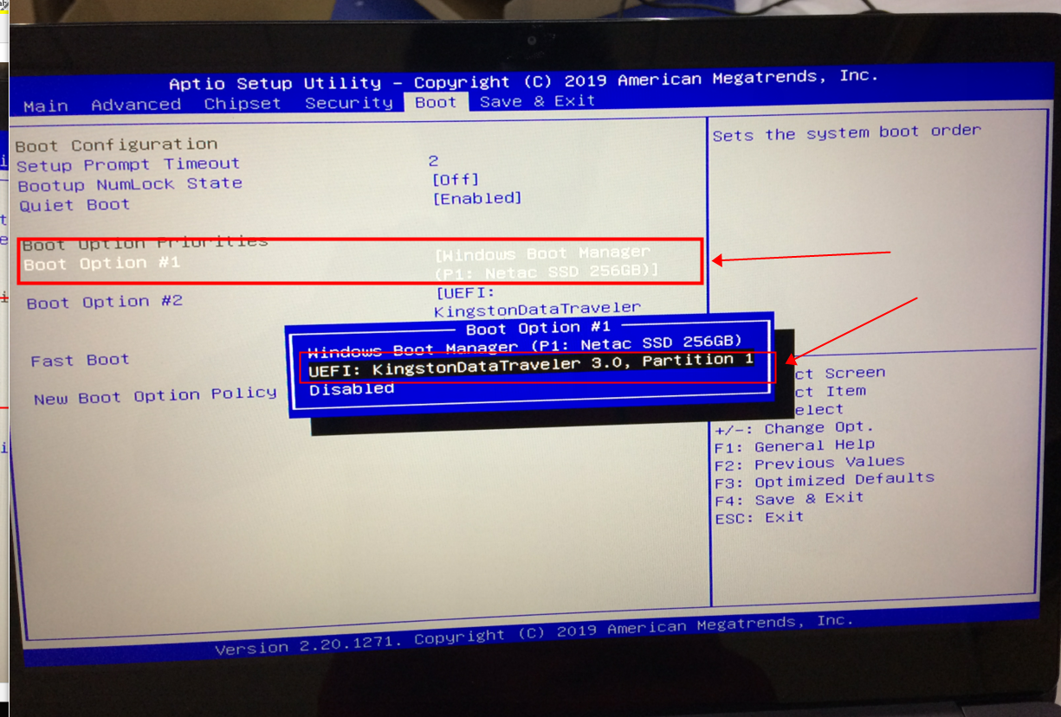

完成了以后进入“Save and Exit”的选项卡，选择第一个选项“Save Changes and Exit”保存退出。
When you are finished entering the "Save and Exit" TAB, select the first option "Save Changes and Exit" to Save and Exit.

