1. Unzip the file and put it in the root directory of the USB drive
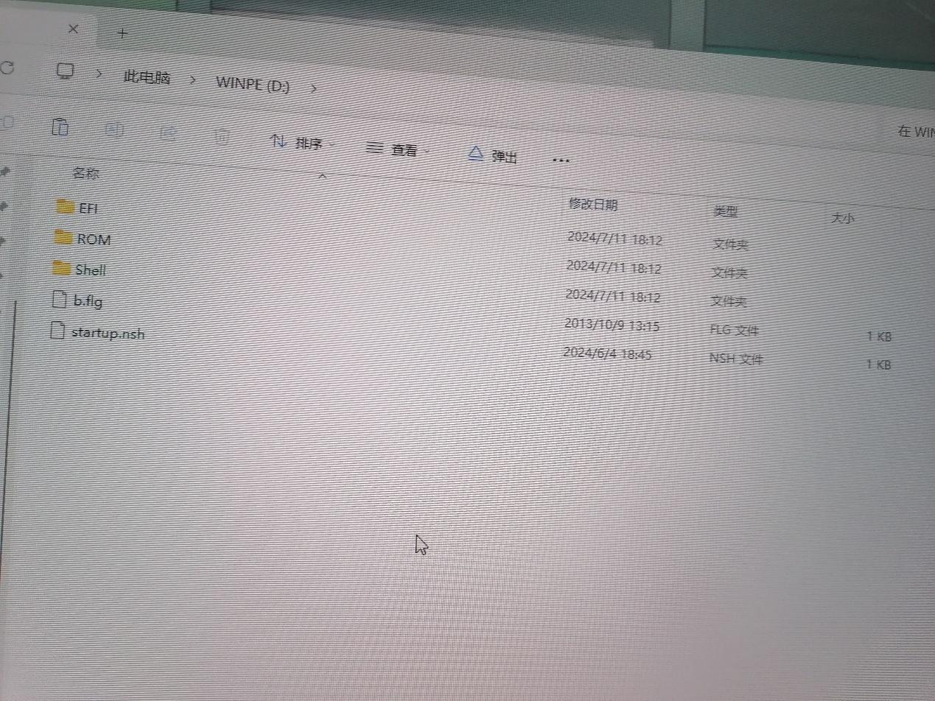
2. Insert the USB drive into the machine, press F7 to enter the flash disk boot interface, select the USB drive and press Enter to start upgrading the BIOS.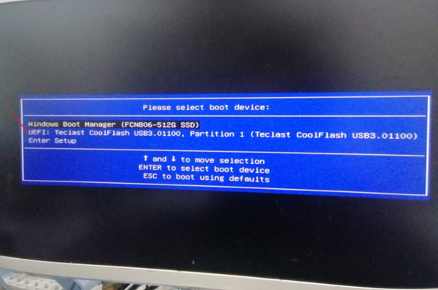3. Do not cut off the power during the BIOS upgrade. The machine will automatically shut down after the upgrade. Unplug the USB drive and restart the machine.
