FLASH BIOS

①：Under “uefi shell” flash BIOS
②：Under “Windows” flash BIOS
Prepare: USB Disk*1----32GB and more than
Software: rufus
1、Open software “rufus”，boot symbol is “ms-dos” click “start”
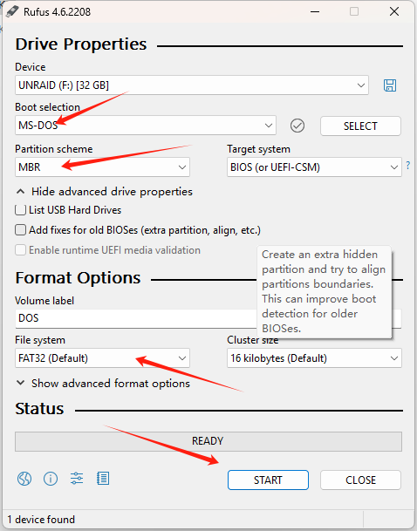
2、Extract the file and place it in the root directory of the USB disk
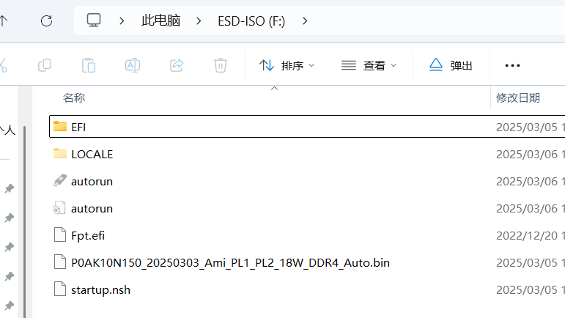
3、Insert USB disk into the computer‘s USB PORT
4、Power computer press F7
5、Selection UEFI :USB DISK

6、Into “shell” will l auto flash BIOS）pay attention to：the flashing process cannot be powered off or shut down
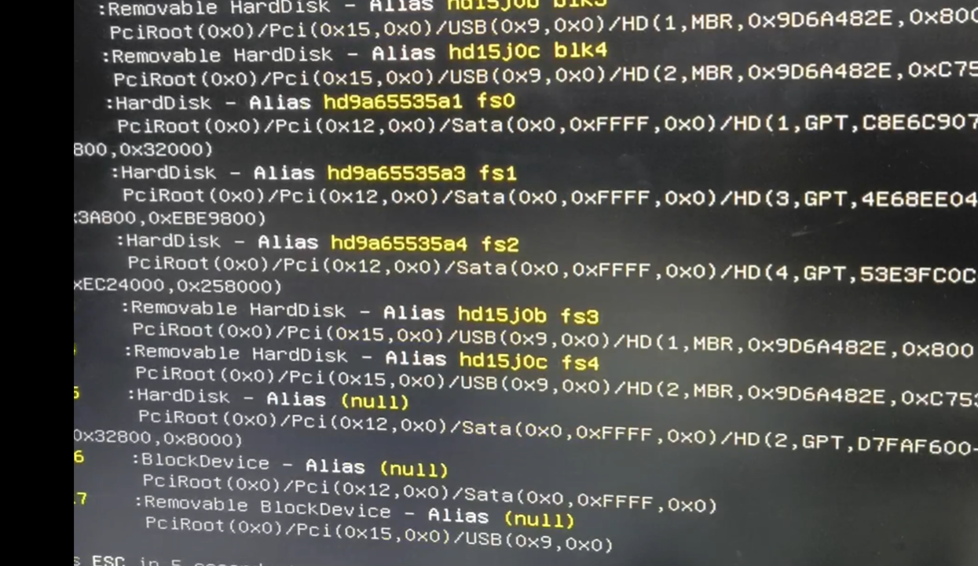
7、FLASH successful

8、Discover the power adapter first，then plug in the adapter and power it on to startup

