G1-25H2 guidance

Creating a System USB Drive
System Installation Method 1
System Installation Method 2
Creating a System USB Drive:
A. Prepare a 16GB or 32GB USB drive.
B. Format the USB drive to FAT32 format (as shown in Figure 1; note: NTFS format cannot boot a system USB drive), and rename it to WINPE.
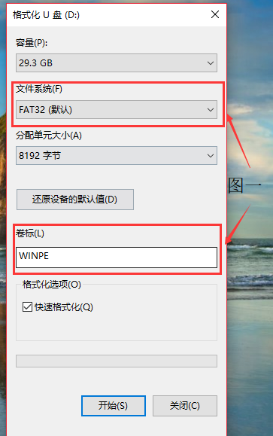

System Installation Method 1:
(Factory-installed system with pre-loaded drivers)
Download the system chain
G1-AMD(8840U-AI 9 HX 370)
Link: https://pan.baidu.com/s/1lrSjg_bUkPRby3Nwr0H51g?pwd=8888 提取码: 8888

Do not download directly to the USB drive. Download to another location first, then copy the files to the root directory of the USB drive.

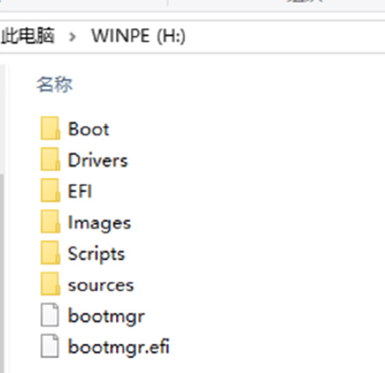
Insert the USB drive with the installed system into the handheld console. Press and hold the power button for 1.5 seconds to boot the device. When the power indicator light illuminates, press the Turbo button (upper right corner) to enter the BIOS boot menu.
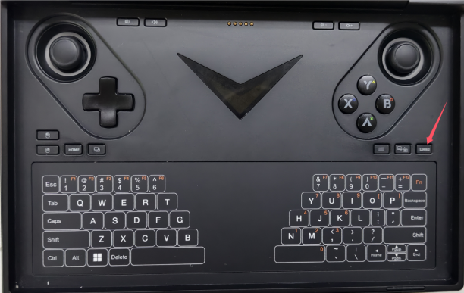
Select the USB drive that appears here (my USB drive is labeled USB partition 1; names may vary for different USB drives).
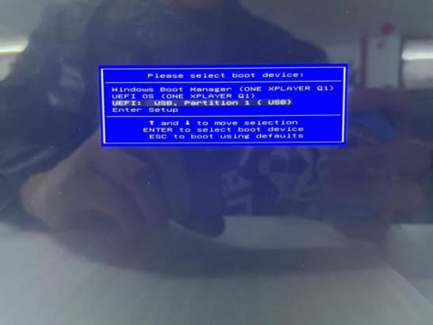
After selecting the corresponding USB drive, press the Enter key or the Start button on the handheld console (requires switching to keyboard and mouse mode) to begin the automatic system installation. Please wait patiently for the installation to complete.
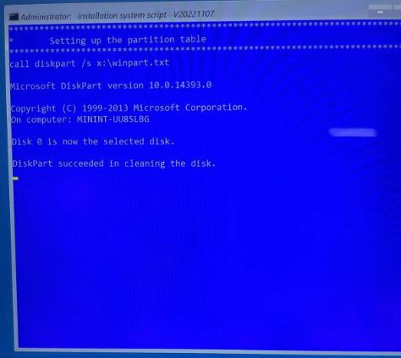
After installation completes, the machine will automatically restart. Remove the USB drive.

Proceed to the language registration screen and follow the prompts to configure language, region, account, password, and other settings.。

Note: After setting your password, you'll be prompted to set up fingerprint or facial recognition. Select Skip!!! You can set these up separately after entering the system.
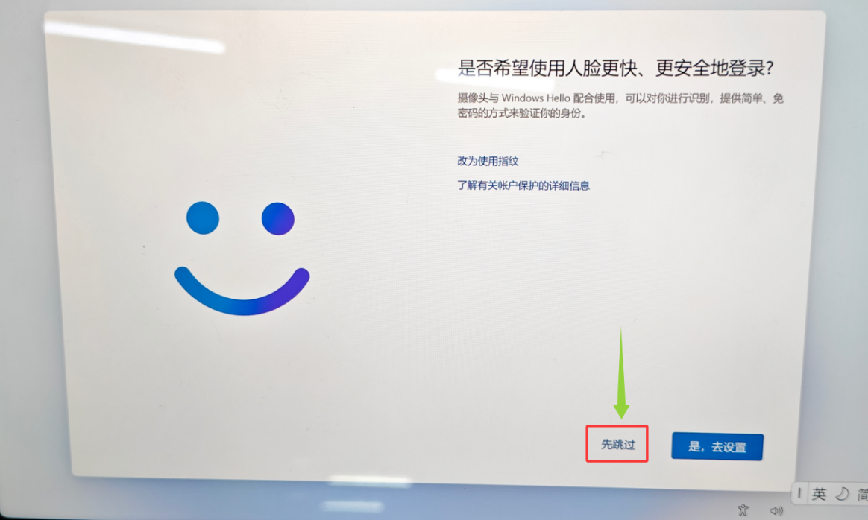

System Installation Method 2:
(No drivers included; must be installed separately)
1. Download the system link
Microsoft official website Windows 11 (25H2) download link (After system installation, you must download the full driver package from the Onexplayer official website):Download Windows 11 (microsoft.com)

2. Insert the USB drive into your computer, open the Windows 11 installation tool, and follow these steps to install:
Select “Accept” for the applicable terms.
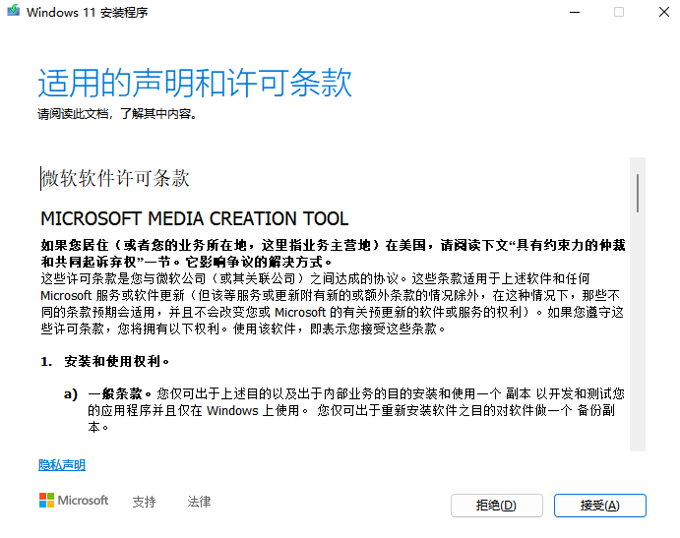

Here, you need to uncheck “Use recommended options for this PC” and change the version to Windows 11.

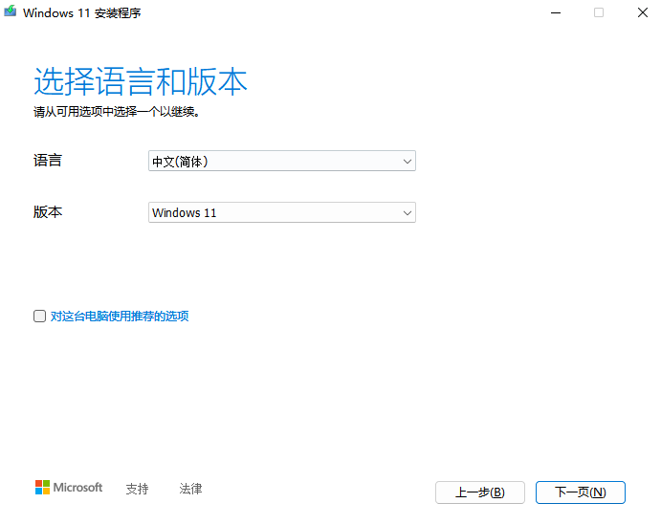

The storage medium installed here is a USB flash drive.
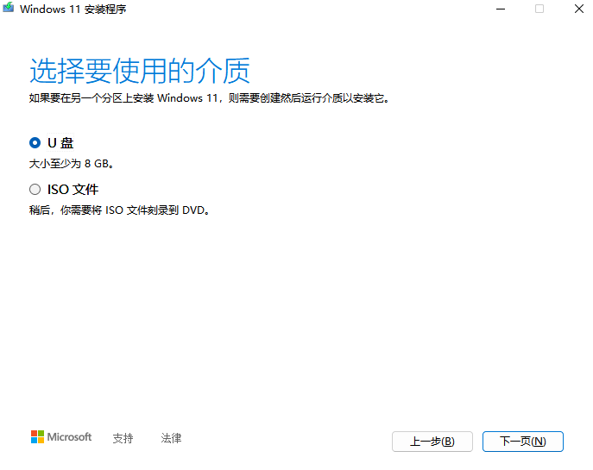
Select the USB drive name that requires a system installation.
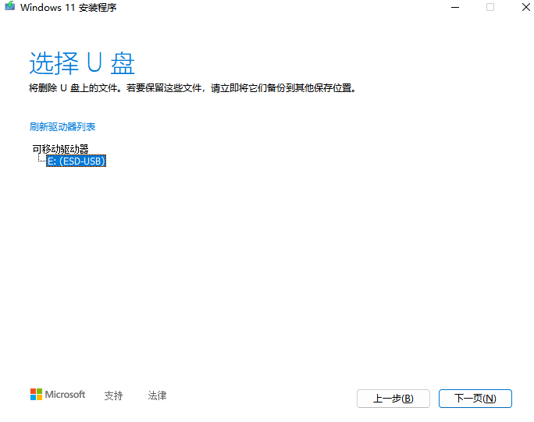
The automatic installation of Windows 11 will now begin. Simply wait patiently for the “Installation and Download” process to complete. Once the download is finished, click “Finish.”
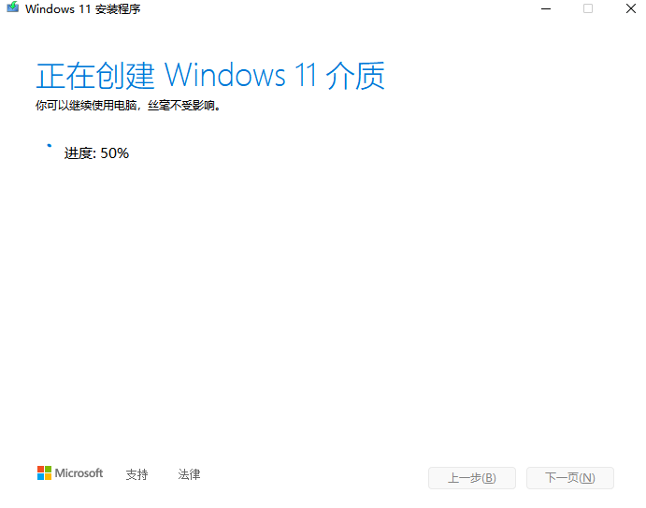
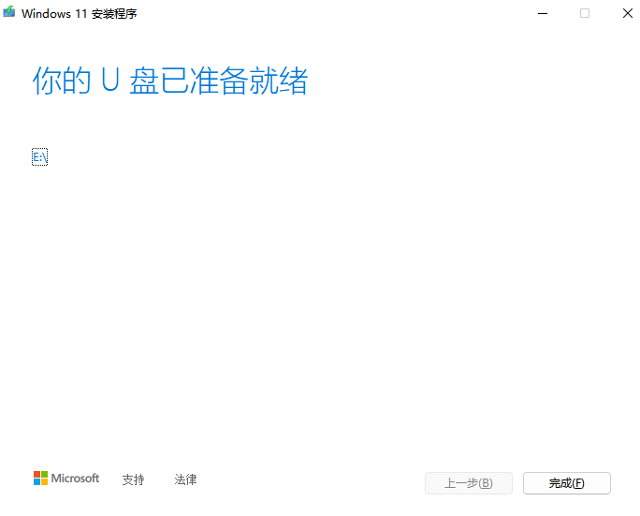
3. Begin Flashing the System
a. Insert the USB drive containing the system into the handheld console. Press and hold the power button for 2 seconds to boot the device. While the power indicator is lit, press and hold the turbo button (the rightmost button on the top of the device).
b. Select the detected USB drive (my USB drive is labeled “USB partition 1”).
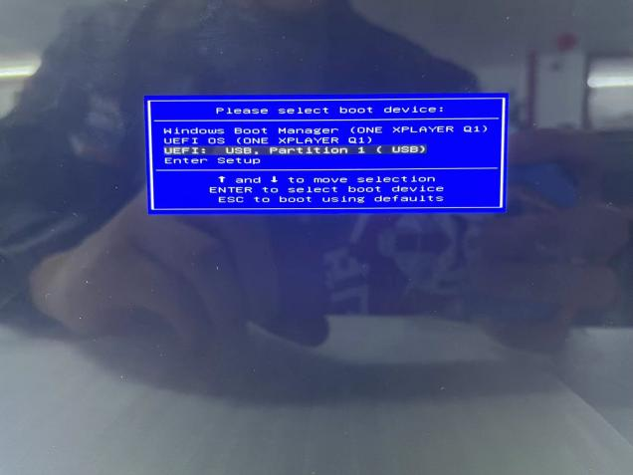

c. Select your preferred language and time zone, then click Next Page.
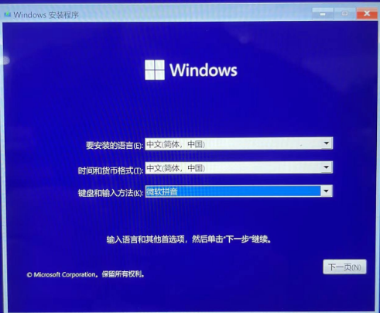
d.Click to install now
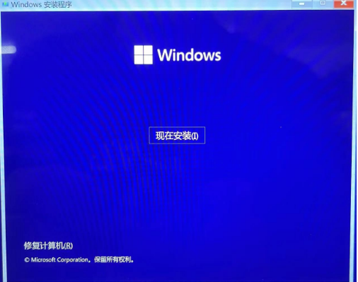
e. After checking the license terms, click Next Page.
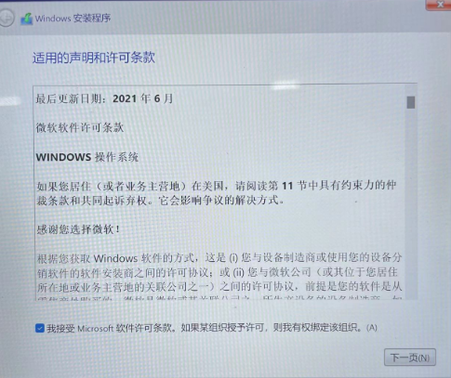

f. Select “Install Windows Only” here.
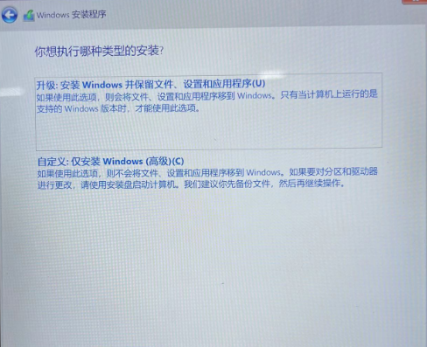

g. Here you enter the disk selection for installation. Select the Windows disk, click Format, and format the disk.
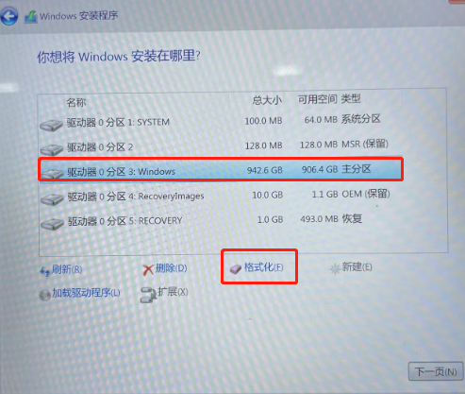
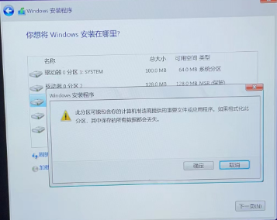

h. Select the Windows drive, click Next, and confirm the installation.
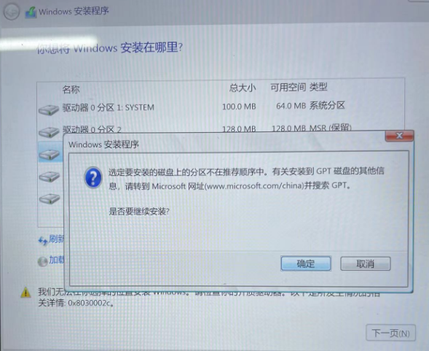

The installation will then begin automatically. Once completed, the program will launch automatically. No further action is required; simply wait patiently.
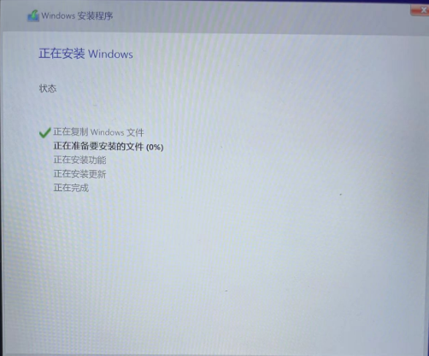

This method is a pure system installation. You need to download and install drivers from the official website (excluding graphics card drivers)：
http://www.onexplayer.com/general/index?configName=download-driver
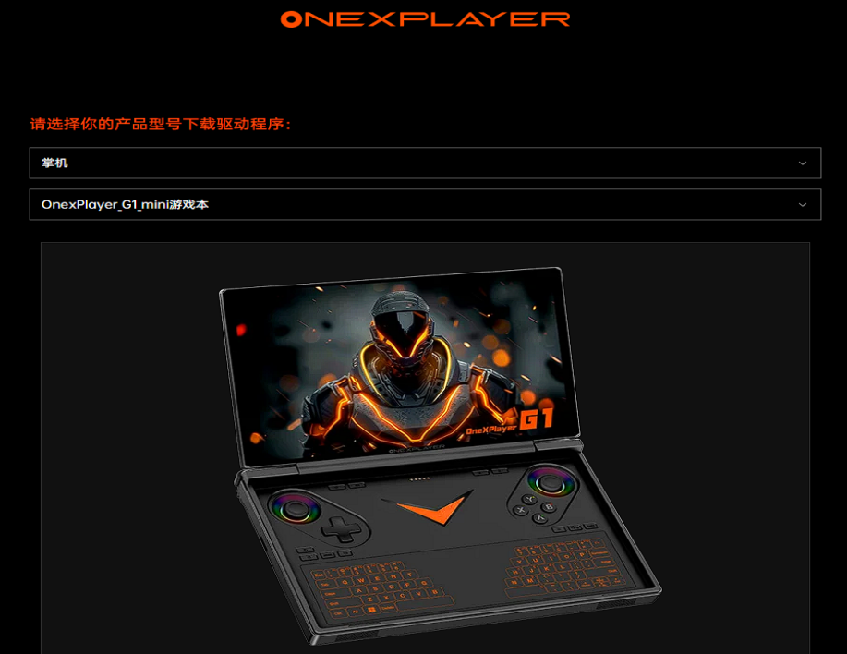

AMD Graphics Card Driver：
https://www.amd.com/zh-cn/support/downloads/drivers.html/processors/ryzen/ryzen-ai-300-series/amd-ryzen-ai-9-hx-370.html

IntelGraphics Card Driver：
https://www.intel.cn/content/www/cn/zh/download/785597/intel-arc-iris-xe-graphics-windows.html

